BLUESTOCK MUTUAL FUND ANALYTICS CAPSTONE PROJECT

FINAL PROJECT REPORT

Prepared By
Srinivasan S

Tools Used
- Python
- Pandas
- NumPy
- SQLite
- SQL
- Matplotlib
- Power BI

1. EXECUTIVE SUMMARY
The objective of this project was to build a comprehensive Mutual Fund Analytics platform capable of analyzing fund performance, investor behavior, portfolio concentration, industry growth, and market trends.
The project combines data engineering, financial analytics, risk analysis, and business intelligence techniques to provide actionable investment insights.
The solution consists of:
- ETL Pipeline
- SQLite Database
- Exploratory Data Analysis
- Performance Analytics
- Advanced Analytics
- Fund Recommendation Engine
- Power BI Dashboard
The final dashboard enables users to evaluate mutual fund schemes, understand risk-adjusted performance, track SIP growth, and monitor investor participation trends.

2. INTRODUCTION
The Indian Mutual Fund Industry has experienced rapid growth in assets under management (AUM), SIP participation, and investor awareness over the last decade.
With thousands of mutual fund schemes available, investors often face challenges in:
- Comparing fund performance
- Evaluating risk
- Selecting suitable funds
- Understanding market trends
This project addresses these challenges through a complete data analytics framework.

3. BUSINESS PROBLEM
Investors require reliable tools to evaluate mutual fund schemes based on performance and risk.
Key business questions:
- Which funds generate the highest risk-adjusted returns?
- Which schemes outperform benchmarks?
- Which investors contribute most to SIP growth?
- Which portfolios have high concentration risk?
- How can investors select suitable funds?

4. PROJECT OBJECTIVES
The objectives of the project were:
- Build automated ETL pipeline
- Store cleaned data in SQLite
- Perform exploratory analysis
- Calculate financial performance metrics
- Evaluate downside risk
- Analyze investor behavior
- Create recommendation engine
- Develop Power BI dashboard

5. PROJECT ARCHITECTURE
Raw Data Sources
↓
Data Cleaning & Transformation
↓
Processed Datasets
↓
SQLite Database
↓
Analytics Engine
↓
Power BI Dashboard
↓
Business Insights

6. DATASET OVERVIEW
The project uses multiple datasets:

Fund Master
Contains scheme details and fund attributes.

NAV History
Daily Net Asset Values for mutual funds.

AUM Data
Assets under management by fund house.

SIP Inflows
Monthly SIP contribution statistics.

Category Inflows
Category-wise investment flows.

Investor Transactions
Investor-level transaction records.

Portfolio Holdings
Stock holdings and sector allocations.

Benchmark Data
Market index performance.

7. DATA CLEANING & ETL PROCESS

Extraction
CSV files imported using Pandas.

Transformation
Cleaning activities performed:
- Missing value handling
- Duplicate removal
- Data type conversion
- Date standardization
- Outlier inspection

Loading
Data stored into:
- Processed CSV files
- SQLite database

8. DATABASE DESIGN
SQLite was used to maintain a centralized repository.
Major tables include:
- fund_master
- nav_history
- aum_data
- category_inflows
- investor_transactions
- portfolio_holdings
- benchmark_indices
Benefits:
- Faster querying
- Centralized storage
- Reproducible analysis

9. EXPLORATORY DATA ANALYSIS
EDA was performed to understand industry trends and fund characteristics.

Industry AUM Growth
Industry assets increased significantly over the analysis period.

SIP Growth
SIP participation showed consistent upward movement.

Category Inflows
Different categories attracted different investor interest.

Fund House Analysis
AUM concentration remained dominated by leading AMCs.

10. PERFORMANCE ANALYTICS
Performance metrics were calculated for all schemes.

CAGR
Measures annualized growth.
CAGR = (Ending NAV / Beginning NAV)^(1/n) − 1

Sharpe Ratio
Measures risk-adjusted return.
Higher values indicate superior performance.

Alpha
Measures excess return relative to benchmark.

Beta
Measures market sensitivity.

Maximum Drawdown
Measures downside risk from peak value.

11. FUND SCORING MODEL
A composite scoring model was developed.
Components:
- Return Rank
- Sharpe Rank
- Alpha Rank
- Drawdown Rank
The resulting Fund Score was used to rank schemes.

12. ADVANCED ANALYTICS

Historical VaR
95% Historical Value at Risk calculated using daily returns.
Purpose:
Estimate maximum expected loss.

Conditional VaR
Average loss beyond VaR threshold.
Purpose:
Measure tail risk.

13. ROLLING SHARPE RATIO ANALYSIS
A 90-day rolling Sharpe Ratio was calculated for selected funds.
Key findings:
- Certain funds maintained consistently high Sharpe Ratios.
- Some funds showed significant volatility.
- Rolling metrics provided better insight than static Sharpe values.
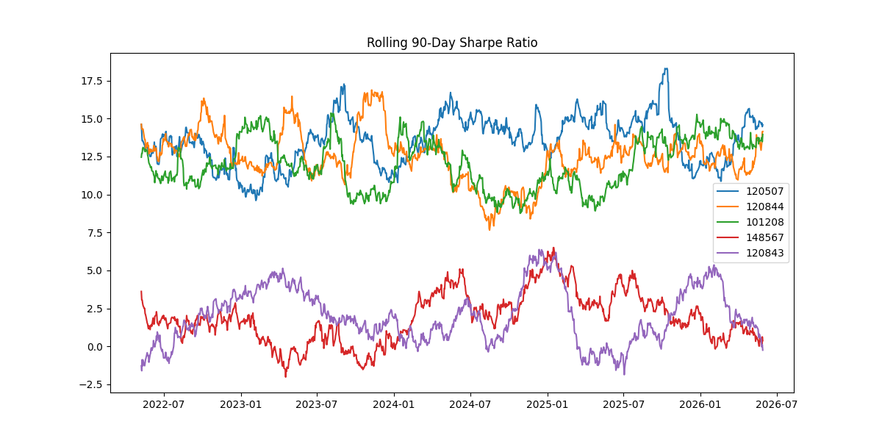

14. INVESTOR ANALYTICS

Cohort Analysis
Investors grouped by first investment year.
Metrics:
- Average investment
- Total invested amount
- Fund preferences

SIP Continuity Analysis
Investors with average gaps greater than 35 days were classified as at-risk.
This helps identify potential investor churn.

15. PORTFOLIO CONCENTRATION ANALYSIS
Herfindahl-Hirschman Index (HHI) was calculated.
Formula:
HHI = Σ(weight²)
Interpretation:
- Low HHI → Diversified portfolio
- High HHI → Concentrated portfolio
Most funds demonstrated moderate diversification.

16. FUND RECOMMENDATION ENGINE
A rule-based recommendation engine was developed.
Inputs:
- Risk Appetite
  - Low
  - Moderate
  - High
Outputs:
- Top 3 Recommended Funds
Recommendation logic used:
- Fund Score
- Sharpe Ratio
- Risk Classification

17. POWER BI DASHBOARD

Page 1 – Industry Overview
Visuals:
- Industry AUM KPI
- SIP KPI
- Folio KPI
- AUM Growth Trend
- Fund House Ranking
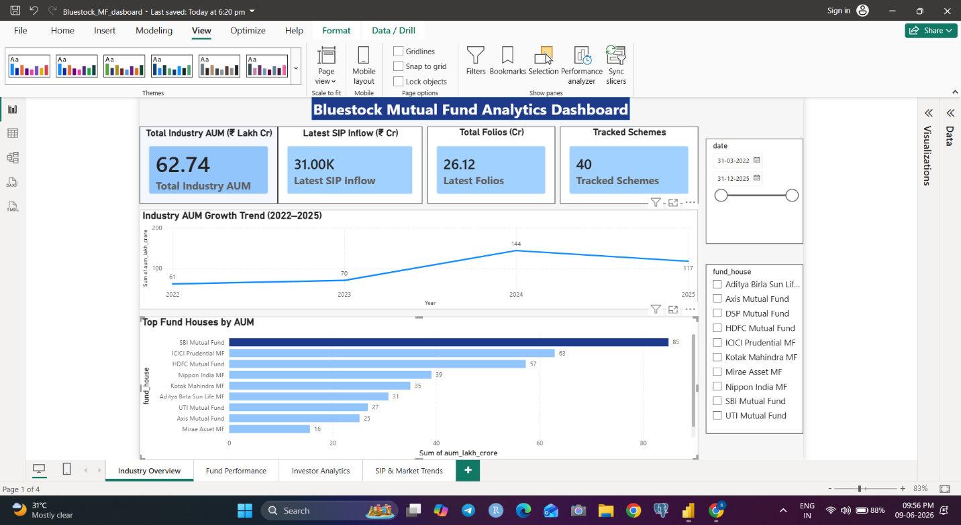

Page 2 – Fund Performance
Visuals:
- Return vs Risk Analysis
- Fund Ranking Scorecard
- NAV Trend
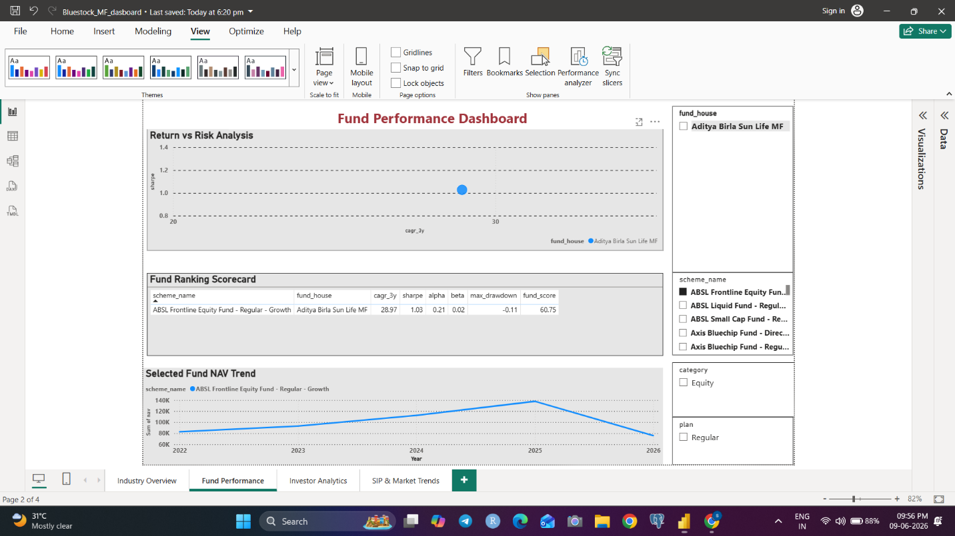

Page 3 – Investor Analytics
Visuals:
- Transaction Volume Trend
- Average SIP by Age Group
- State-wise Analysis
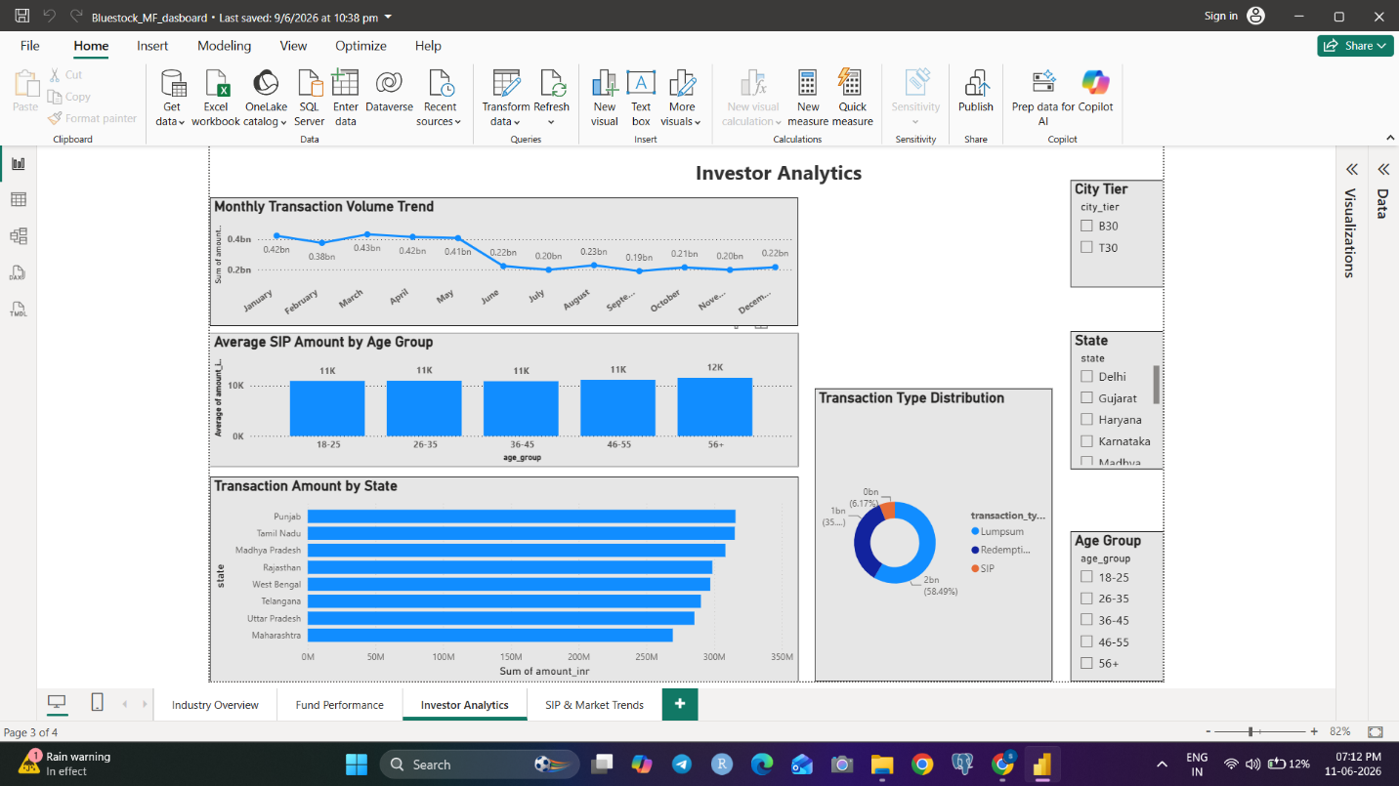

Page 4 – SIP & Market Trends
Visuals:
- Category Heatmap
- SIP vs NIFTY Trend
- Top Categories by Net Inflow
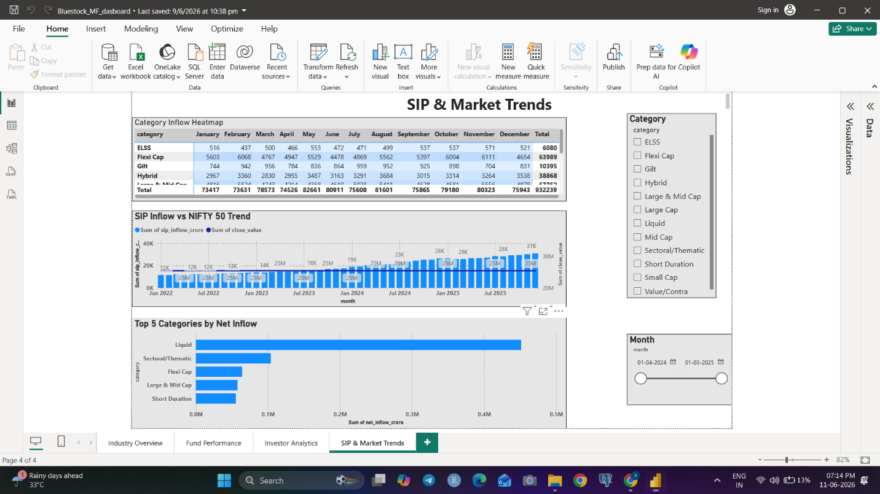

18. KEY INSIGHTS
- High Sharpe Ratio funds generated superior risk-adjusted returns.
- Industry AUM growth indicates increasing investor confidence.
- SIP participation continues to grow steadily.
- Some funds exhibit elevated downside risk according to VaR.
- Most portfolios remain reasonably diversified.
- New investor cohorts contribute significant investments.
- SIP continuity analysis identifies at-risk investors.

19. RECOMMENDATIONS
- Prioritize funds with strong Sharpe Ratios.
- Monitor VaR and CVaR regularly.
- Improve SIP retention strategies.
- Encourage diversification.
- Use benchmark-relative analysis for decision making.

20. CONCLUSION
This project successfully developed a complete Mutual Fund Analytics framework integrating ETL, database management, performance analytics, advanced risk analysis, investor analytics, and Power BI dashboarding.
The solution provides valuable insights for investors, analysts, and fund managers and demonstrates practical application of data analytics in the financial domain.

FUTURE SCOPE
- Monte Carlo Simulation
- Efficient Frontier Optimization
- Streamlit Web Application
- Automated Reporting
- Real-Time NAV Integration

